Switching java version
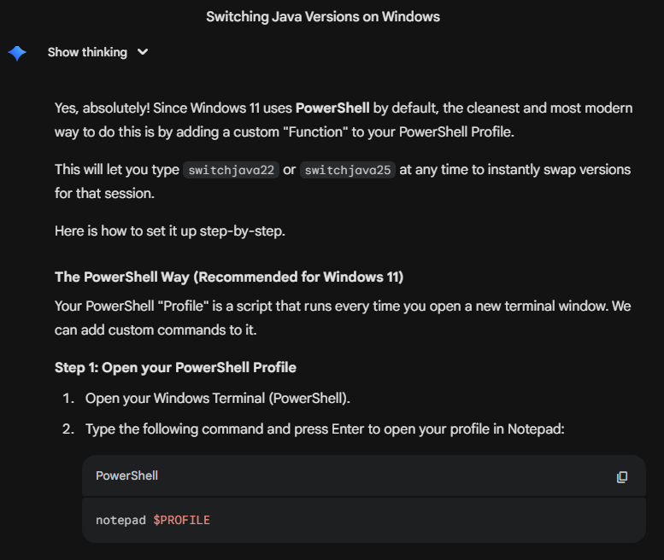

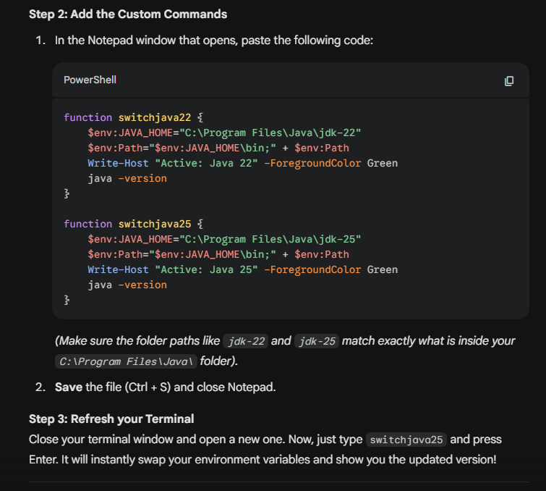

Code:

function switchjava22 {
$env:JAVA_HOME="C:\Program Files\Java\jdk-22"
$env:Path="$env:JAVA_HOME\bin;" + $env:Path
Write-Host "Active: Java 22" -ForegroundColor Green
java -version
}

function switchjava25 {
$env:JAVA_HOME="C:\Program Files\Java\jdk-25"
$env:Path="$env:JAVA_HOME\bin;" + $env:Path
Write-Host "Active: Java 25" -ForegroundColor Green
java -version
}

Set in the terminal:

The Command Prompt (cmd) Way
If you prefer using the older Command Prompt instead of PowerShell, the profile method above won't work. Instead, you create tiny scripts.
- Create a new folder on your C: drive called C:\Scripts.
- Open Notepad and paste this code:

---------------------------------------
@echo off
set JAVA_HOME=C:\Program Files\Java\jdk-22
set PATH=%JAVA_HOME%\bin;%PATH%
echo Switched to Java 22
java -version

- Save it as switchjava22.bat inside C:\Scripts.
- Create a second file with the Java 25 paths and save it as switchjava25.bat in the same folder.
- Search for "Environment Variables" in your Windows Start menu and open it.
- Under "User variables", find the variable named Path, select it, and click Edit.
- Click New, type C:\Scripts, and click OK on all the windows.
